SIMATS ENGINEERING (SAVEETHA SCHOOL OF ENGINEERING)
Department of Computer Science and Engineering
ASSESSMENT TOOL 1 – PSEUDOCODE WRITING TASK

Course Code: | CSA0305 | Course Title: |  | Data Structures
CO Assessed: | CO5 – Naturalization (BL4, BL6) | Assessment: |  | Assessment Tool 1 – Pseudocode Writing Task
Weightage: | 35% of CIA | Total Marks: |  | 100
CO5 Statement: | Construct MST using shortest path algorithms and traverse the graph to model and analyse realworld problem.
Student Name: | K.Kabilan |  | Reg. No.: | 192521157
Section / Batch: | B.tech-IT |  | Date: | 31/08/2026

Code of Conduct
I __________K.Kabilan (192521157)_________________________________________________________________________________ (Name / Reg No) certify that this submission is my original work and that I have adhered to the guidelines specified for this assessment. I understand that any violation of academic integrity rules will result in disciplinary action.
Signature of the Student: ____________K.Kabilan_____________

Instructions
- This test contains 5 Pseudocode Writing Task questions. Total: 100 Marks.
- When a student answer using pseudocode writing task should evaluate based on the ability to design clear, logical, and efficient pseudocode solutions for data structure problems.
- No negative marking. Unanswered questions carry zero marks.

Section / Topic | Focus | Q Nos | Marks
Minimum Spanning Tree | Kruskal’s Algorithm | 1 | 20
Graph Sorting | Topological Sort | 2 | 20
Shortest Path Algorithm | MST & Dijkstra’s Algorithm | 3 | 20
Shortest Path Algorithm | Dijkstra’s Algorithm | 4 | 20
Minimum Spanning Tree | Prim’s or Kruskal’s Algorithm | 5 | 20
 | GRAND TOTAL: | 100 Marks

Rubrics for Calculation
Criteria | Weightage | Level 4 – Exemplary |  | Level 3 –  Proficient | Level 2 –  Developing |  | Level 1 –  Beginning
Problem  Understanding | 20 | Demonstrates complete and clear understanding; handles edge cases effectively |  | Good understanding; minor gaps in edge case handling | Partial understanding; misses some requirements |  | Misinterprets problem; major gaps
Code  Correctness | 30 | Fully correct; passes all test cases |  | Mostly correct; minor errors | Partially correct; several test cases fail |  | Incorrect or nonfunctional code
Code Quality & Readability | 20 | Clean, modular, wellcommented, follows standards |  | Readable with some structure | Limited readability; poor structure |  | Unorganized and hard to read
Complexity Analysis | 20 | Accurate time & space complexity with justification |  | Correct but limited explanation | Incomplete or partially correct |  | Missing or incorrect
Testing & Validation | 10 | Thorough testing including edge cases |  | Adequate testing with few edge  cases | Minimal testing |  | No testing evidence
Faculty In-charge |  |  | Course Coordinator |  |  | Program Director
Signature: _______________ |  |  | Signature: _______________ |  |  | Signature: _______________
Date: ___________________ |  |  | Date: ___________________ |  |  | Date: ___________________
1)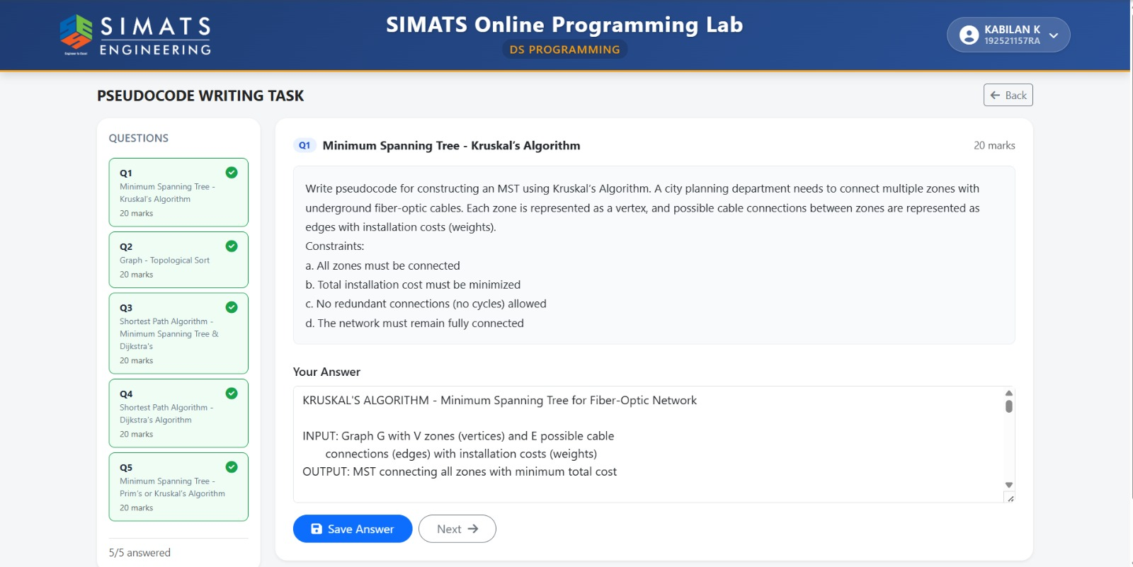

2)

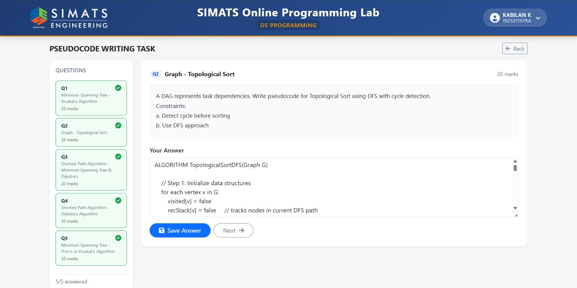

3)

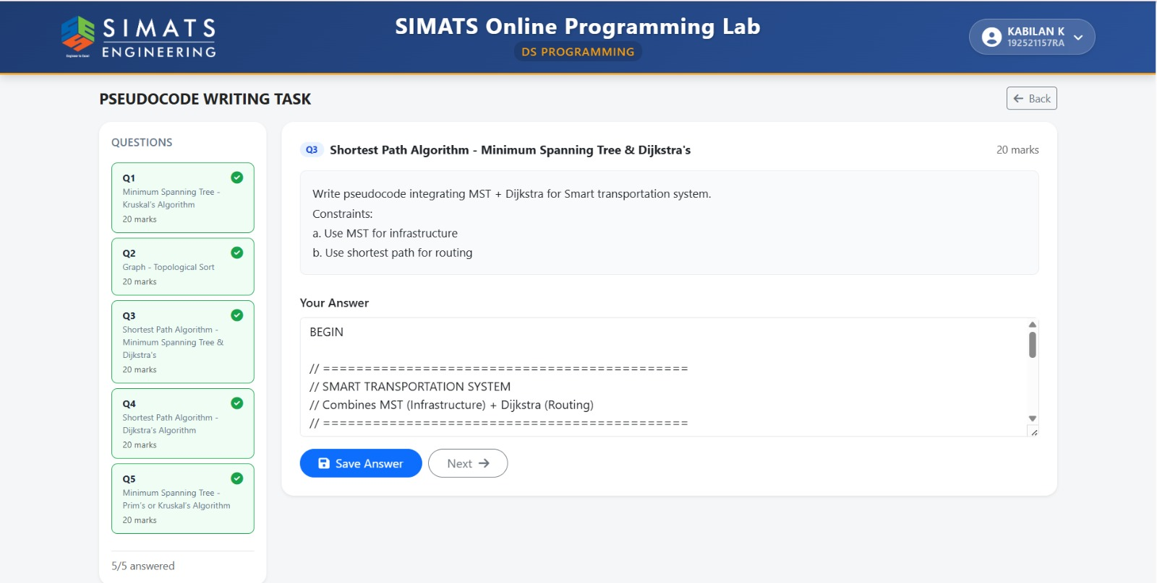

4)

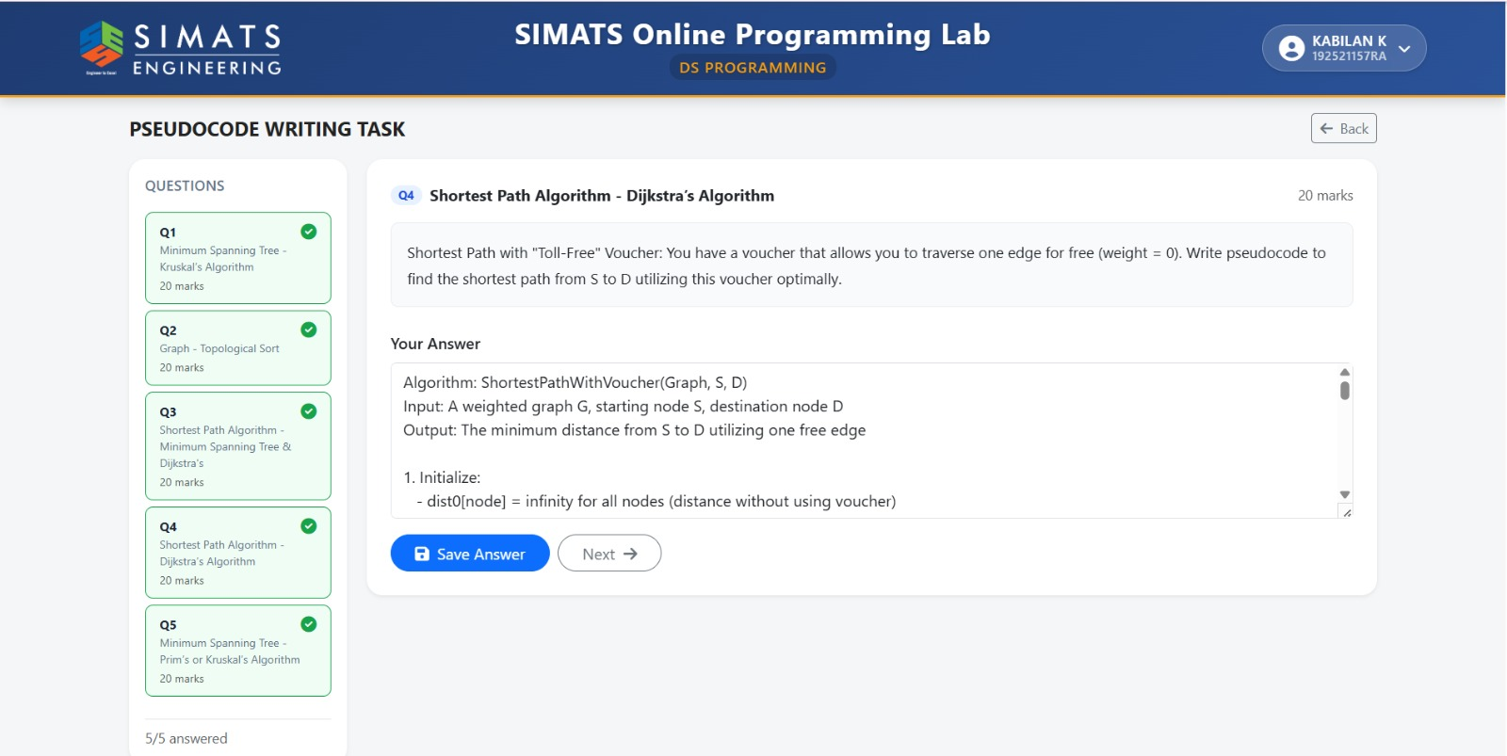

5)

